1.

For the evolution point of view, when people divided more than one country after 1947 when Pakistan came into being. People who speak Urdu divided into two sides of coin India and Pakistan. I would like to point out the evaluation from India perspective because the origin was from there too. It is fairly unusual that the Urdu language picked up the cash first in the South. In 1327 Muhammad Tughlaq attacked Deccan and established Daultabad as his capital. Hasan Bahmani who opposed the Tughlaq ruler and set up a Bahmani realm assumed a significant job.

Furthermore, In Deccan Urdu language came into contact with Marathi, Telugu, and Kanarese have spoken by the nearby individuals. Explain­ing the purposes behind the development of Urdu in Deccan Prof. S.R. Sharma says, "Particularly after the ascent of the Bahmani realm the local Muslims of the South wished to be as independent as conceivable from the royal capital and they built up a nearby enthusiasm with a longing to underscore their own life and methods of thought, and finally they started to speculate and hate untouchables. This brought about the development of Urdu instead of Persian, which was the language of the Emperor's Court.

2.

Sound:-

Urdu utilizes the Arabic content with expansions to covers its a lot more extensive collection of sounds. Some of the augmentations depend on those produced for Farsi.

A portion of the consonant characters two-fold as long vowels (eg. ی and و). The vowels are not for the most part obviously characterized, however, when important, vowel data can be spoken to by joining marks showing up above or underneath the base consonant. The nonappearance of a vowel and multiplying of consonants can be demonstrated similarly.

The letters in order to incorporate suctioned letters that must be made with two Unicode characters and a Je letter that utilizes distinctive Unicode characters relying upon the specific situation.

In spite of the fact that it isn't in every case simple to figure the vowel sounds in a word, the consonants are to a great extent dependable phonetically. There is, for the most part, a balanced correspondence among letters and sounds.

Words:-

Nearly everybody knows about the Urdu langauge because absence of mandatory dictionarieds and imporatnt material, which is consistently unimaginable, verifiably erroneous and etymologically deceptive. Regardless of the reality about who offered this expression, why it was made and when it was started just because one thing needed to be said with most extreme conviction that it has signed the socio-political and socio-etymological effect in the Indian Subcontinent throughout the previous 150 years, i.e., with the coming of British Raj right now.

One can make a deductions from this lie which has molded our recognition, deliberately and sub-intentionally that Urdu is definitely not a Hindustani people Subcontinent rather it's a language of remote intruders. Thusly it must be abandoned if not abhorred.

Sentences:

In my porspective, every things based on some rule that must follow in orde to satisfy the condition under some assumptions.it will be easy for you to understand hundreds of simple sentences used in daily conversation.

Likewise, we need to look on some dialect where Urdu language taken some words from

**Basic Structure of English Sentence:**

S + O + V

( I + run + fast)

**Basic Structure of Arabic Sentence:**

V + S + O

( sleep + I + early)

*Urdu structure with examples.*

**Basic Structure of Urdu Sentence:**

S + O + V

( I + pineapple + throw )   - Present Indefinet Tense

Examples:

(Main + subah+ khata hn)

(Main + University + jata hn)

(Wo + kaam + Karta hy)

Having the structure of the Urdu language sentence you can build the grammar according to this example and make your own. In addition, it also includes syntax which helps to make the rules for grammar and impose such restrictions over a language such as over ***Urdu***.

Phonetics:

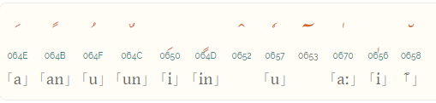

It is supposed to give extra sounds in Urdu,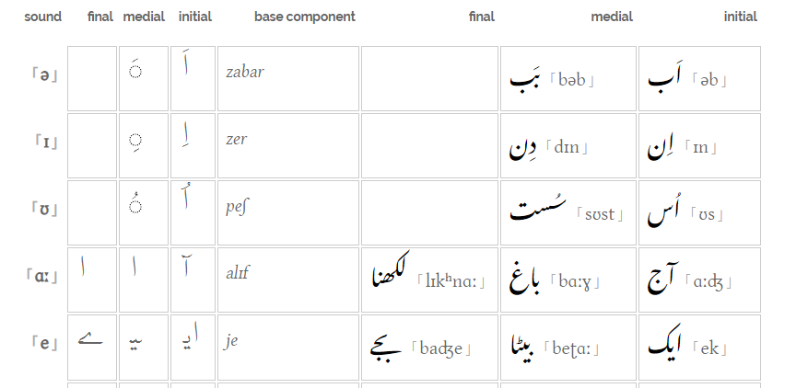 contrasted with Arabic, the manner in which characters are utilized to communicate vowels is considerably more entangled. The accompanying table shows the standard methods for demonstrating sounds and shows what would be utilized in the event that they appeared. Note in any case, that setting can change the estimation of a vowel diacritic, (for example, an after 'ain or he) – these are point by point beneath the table. Three short vowels are not regularly found in inconclusive positions.

Indeed, It is hard to guess the sounds inside the langauge.There is mostly a one-to-one correspondence between letters and sounds.

Text Direction:

Although it is not important to mention it is one of the major distinction which makes it unique from other languages.

Arabic content is composed on a level plane and option to-left in the fundamental, yet similarly as with most RTL contents, numbers and installed LTR content is composed left-to-right (delivering 'bidirectional' content).

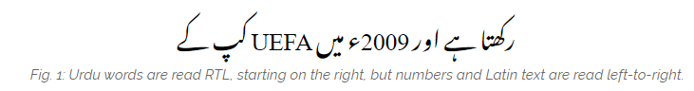

Unicode gives a lot of 10 arranging characters that can be utilized to control the heading of content when shown. These are recorded in the article How to utilize Unicode controls for bidi content.

3.

**Literature:**

Urdu writing (Urdu: ادبیات اردو‎, "Adbiyāt-I Urdū") is writing in the Urdu language. While it will, in general, be overwhelmed by verse, particularly the refrain types of the ghazal غزل and nazm نظم, it has ventured into different styles of composing, including that of the short story, or afsana افسانہ. Urdu writing is for the most part well known in Pakistan, where Urdu is the national language and India, where it is an official language. It is likewise broadly comprehended in Afghanistan.

Urdu created in the Delhi area. Urdu writing began sometime around the fourteenth century right now India among the advanced upper class of the courts. The proceeding with customs of Islam and patronizations of remote culture hundreds of years sooner by Muslim rulers, as a rule of Turkic or Afghan drop denoted their effect on the Urdu language given that both social legacies were firmly present all through the Urdu domain. The Urdu language, with a jargon, uniformly split between Sanskrit-determined Prakrit and Arabo-Persian the word was an impression of this social amalgamation.

**Ethnic and Linguistic Diversity:**

These four fundamental ethnic gatherings are additionally isolated into different subcategories, linguistic gatherings, and positions. The primary dialects incorporate Urdu, Punjabi, Pashtu, Balochi, Sindhi, Seraiki, Hindko, Dari, and Gujrati. Urdu, the national language, is the primary language of just a small amount of the populace in spite of the fact that itis broadly comprehended. In fact, the vast majority communicate in their local language, and Urdu, with the practically equivalent facility. While the key ethnic gatherings are commonly amassed in their provinces,signiﬁcant numbers are found in different territories, and furthermore over the outskirts in neighboring Iran, Afghanistan, and India. Furthermore, inside every territory, there is a considerable ethnic and etymological decent variety. Punjab has a huge number of Saraiki-talking individuals who demand their different character from the Punjabis. Sindh has a signiﬁcant extent of Balochis, Bihari displaced people from Bangladesh, Seraikis in the north, and an enormous fixation in urban Sindhof Muhajirs—the Urdu-talking vagrants who came to Pakistan after 1947.The NWFP has some Hindko-talking individuals, the Hazaras, and some Seraikispeakers. Balochistan has countless Pashtuns other than Brahui-and Dari-talking networks and Punjabi pioneers

Figure 1 exhibits a review of ethnic decent variety in Pakistani society, which is generally isomorphous with phonetic assorted variety. Most ethnic gatherings establish a majority in their general vicinity of the starting point (region or district): they are indigenous to it but comprise a minority inside different locales, and furthermore in contrast with the entire population.12Faced with a decent variety of ethnic and phonetic groups, Pakistan's national solidarity is predominantly founded on Islamic political and geographical factors. Islam and the Urdu language fill in as major binding together factors. However, the etymological and ethnic identiﬁcation in Pakistani society has been traditionally portrayed by power legislative issues, and segregation in organizations and other cultural contexts.13Pakistan's the constitution doesn't recognize the job of any ethnic and linguistic character in the make-up and organization of the general public. Punjabis dominate strategically, however, the other ethnic-semantic networks don't accept the marker of minorities—rather, demanding that they are nationalities. Indeed, even the Urdu-speaking Muhajirs in Sindh demands being perceived as a distinct nationality. Anyway as the Punjabis dwarf every one of these networks

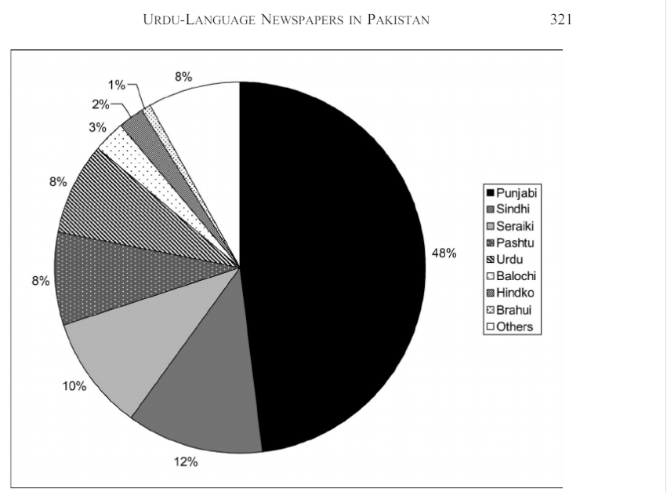

4.

Impact of social groups like Sunni, Shia, Deoband Hazrat.  They are commonly known as social groups in the Urdu community. Where My ancestors told me about them. Like Sunni uses to believe in Our holly prophet PBUH and amal on their sunnah. On the other hand, Shia people believe in Panjatan Pak and 12 imams. These are the social groups mostly find in the Urdu community In Pakistan. Furthermore,  when we migrate even when we are in the same community but different ethnicity we found out distinction among them.

Education point of view, It is hard to differentiate because education does not clarify Urdu. Because I asked my ancestors and I noticed myself in university. There was not any difference because we were not supposed to talk to our mother tongue during the class and timestamp of the university.

5.

It was hard at first getting to know about our native language but when we started it was likely to love this kinda session. First of all, we started off knowing about the ancestral language I came to know personally the origin of our language when my ancestors started to tell the adages when they were in India. Their language was so pure when they were around a single community of Urdu people only. Their accent was different than now. In the meantime, when they moved here it was new experience when mingling with different ethnicity or culture likewise, Punjabi, Sindhi, etc.

<https://r12a.github.io/scripts/arabic/urdu>

<https://www.dawn.com/news/672945/language-urdu-and-the-borrowed-words>

<https://www.italki.com/discussion/50894?hl=en>

<https://www.researchgate.net/publication/295902694_The_Representation_of_Cultural_Diversity_in_Urdu-Language_Newspapers_in_Pakistan_A_Study_of_Jang_and_Nawaiwaqt>

<https://en.wikipedia.org/wiki/Urdu_literature>